
Written Exam term 4 – 2015 Name:__________________
Year 9 Mark /99
Show working and answers on this sheet. Show working in sufficient detail to support your answers. Incorrect answers without supporting reasoning may be allocated zero marks. Formula sheet (1 A4 sheet double sided) and calculators may be used for this part.

1 Find the values of the angles and/or pronumerals in each diagram, give reasons.
a (3 marks) Find x.
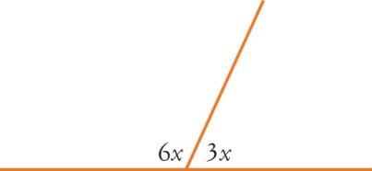
________________________________________
________________________________________
________________________________________
b (3 marks) Find n.
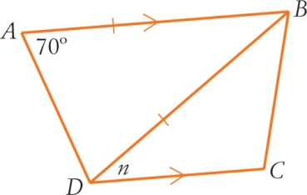
________________________________________
________________________________________
________________________________________
________________________________________

c (3 marks) Find y.
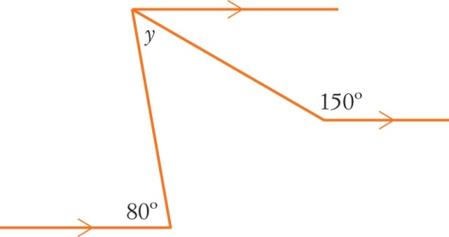
________________________________________
________________________________________
________________________________________
________________________________________
d (5 marks) Find x and y.
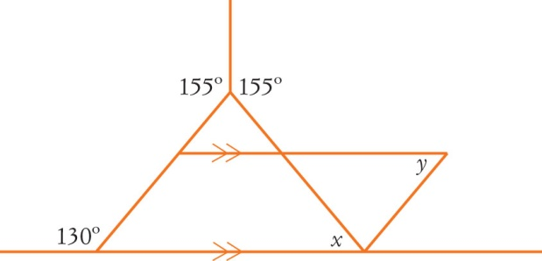
________________________________________
________________________________________
________________________________________
________________________________________
________________________________________
________________________________________

2 Find the value of each pronumeral.

a b
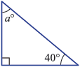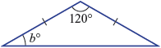

__________________________________ __________________________________

__________________________________ __________________________________

c d
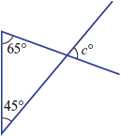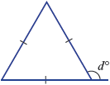

__________________________________ __________________________________

__________________________________ __________________________________

(4 × 2 = 8 marks)

3 Find the value of each of the pronumerals. Give reasons for your answers.

a b
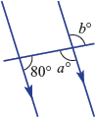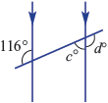

__________________________________ __________________________________

__________________________________ __________________________________
(3 + 3 = 6 marks)

4 Find the value of the pronumeral in each of these polygons.
a b
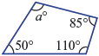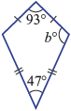

__________________________________ __________________________________

__________________________________ __________________________________

__________________________________ __________________________________

c d

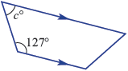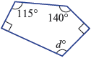

__________________________________ __________________________________

__________________________________ __________________________________

__________________________________ __________________________________

(3 × 2 + 3 = 9 marks)
5 This pair of figures are similar.
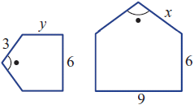

a Find a scale factor.

_____________________________________________________________________________________

b Find the value of x.

_____________________________________________________________________________________

c Find the value of y.

_____________________________________________________________________________________

(2 + 2 + 2 = 6 marks)
6 Find the length of the hypotenuse in each of the following right-angled triangles, leaving your answer to part b to 2 dp.
a b
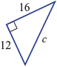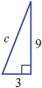
_______________________________________ _____________________________________

_______________________________________ _____________________________________

_______________________________________ _____________________________________
(2 + 2 = 4 marks)

7 Find the value of the pronumeral in each of the following right-angled triangle, leaving your answer to part b to 2 dp
a b
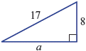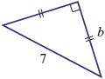

_______________________________________ _____________________________________

_______________________________________ _____________________________________

_______________________________________ _____________________________________
(2 + 2 = 4 marks)
4 In each of the following, find the value of x correct to two decimal places.
a cos 70° = b = tan 28°

_______________________________________ _____________________________________

_______________________________________ _____________________________________

_______________________________________ _____________________________________

c sin 34° = d = cos 59.6°

_______________________________________ _____________________________________

_______________________________________ _____________________________________

_______________________________________ ___________________________________
(4 × 2 = 8 marks)

8 (4 marks each) Find the values of the
pronumerals in each triangle. Express angles and answers to 2 dp.
a 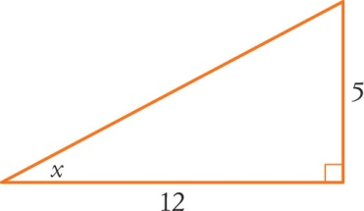
________________________________________
________________________________________
________________________________________
________________________________________
________________________________________
b 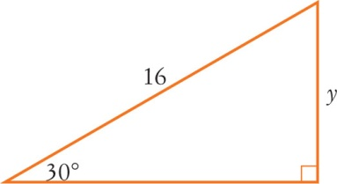
________________________________________
________________________________________
________________________________________
________________________________________
________________________________________
c 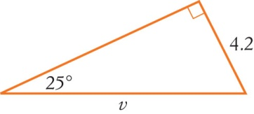
________________________________________
________________________________________
________________________________________
________________________________________
________________________________________
________________________________________

d 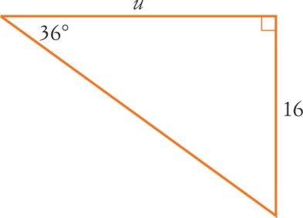
________________________________________
________________________________________
________________________________________
________________________________________
________________________________________
________________________________________
________________________________________
________________________________________
e 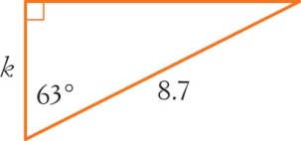
________________________________________
________________________________________
________________________________________
________________________________________
________________________________________
________________________________________
________________________________________
________________________________________
________________________________________
________________________________________

9 (5 marks) A 2.5 m long ladder leans against a 3.0 m high wall. If it rests against the (horizontal) ground at an angle of 75°, how far from the top of the wall will it reach? Use the space to the right of the diagram for working.
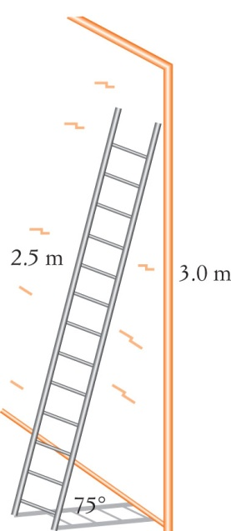
________________________________________
________________________________________
________________________________________
________________________________________
________________________________________
________________________________________
________________________________________
________________________________________

10 A ramp is made from a rectangular piece of
wood which is 1.8 m long. It connects a 75 cm
high platform to the ground.
a (3 marks) How far away (horizontally) from the edge of the platform is the start of the ramp?
Draw a diagram
________________________________________
________________________________________
________________________________________
________________________________________
________________________________________

b (3 marks) At what angle is the ramp rising (to the horizontal)?
________________________________________
________________________________________
________________________________________
________________________________________

11 A pilot flying a plane at an altitude of 1790 m sees a mountain peak 2540 m high, 2800 m away from him in the horizontal direction.
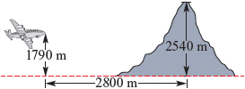

a What is the difference in the vertical height between the plane and mountain peak?

_______________________________________________________________________________________

_______________________________________________________________________________________

b Find the direct distance between the plane and the mountain peak, correct to the nearest metre.

_______________________________________________________________________________________

_______________________________________________________________________________________

_______________________________________________________________________________________

c If the pilot flies straight for another 400m find the angle the pilot would now have to climb at to just miss hitting the mountain peak(** round to the nearest degree). Would you round up or down and why?

_______________________________________________________________________________________

_______________________________________________________________________________________

_______________________________________________________________________________________

_______________________________________________________________________________________
(2 + 3 + 4 = 9 marks)

